Wie woont hier?

[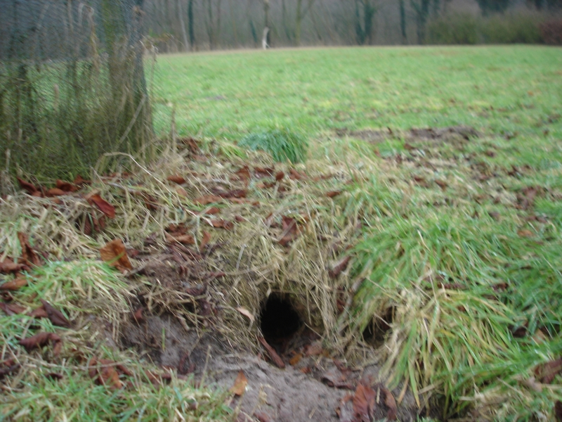](http://www.google.nl/url?sa=i&rct=j&q=&esrc=s&source=images&cd=&cad=rja&uact=8&ved=0ahUKEwj0s6W065_WAhVHblAKHf20CB4QjRwIBw&url=http%3A%2F%2Fwww.achterhoekeengedicht.nl%2FLogs%25202010%2Ffebr2010.htm&psig=AFQjCNFmJ1YjkvrvoSNTStdAibRjV55Q8g&ust=1505312283862948)

Wie woont hier?

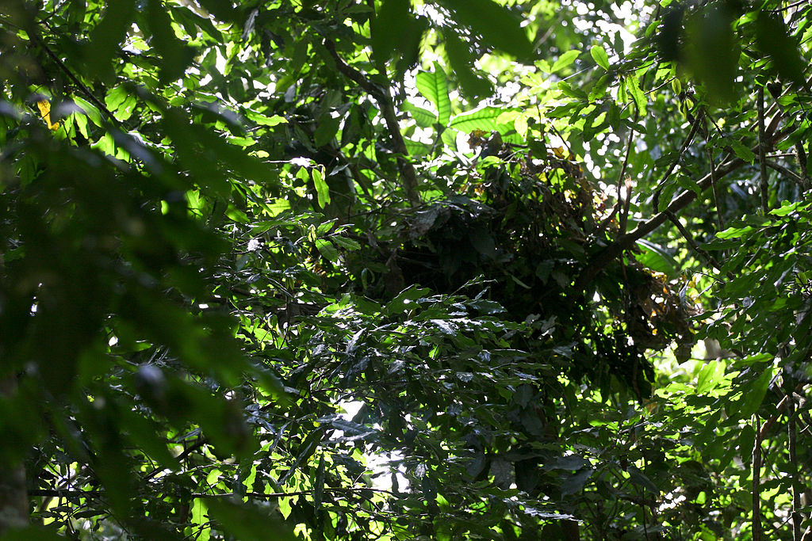

Wie woont hier?

[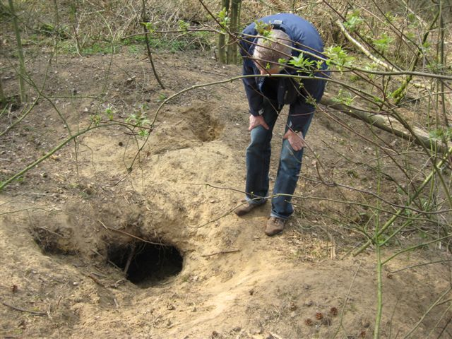](http://www.google.nl/url?sa=i&rct=j&q=&esrc=s&source=images&cd=&cad=rja&uact=8&ved=0ahUKEwiKlvuZ7J_WAhXLKVAKHQOvCdQQjRwIBw&url=http%3A%2F%2Fwww.diak72.nl%2F2011_maart.htm&psig=AFQjCNGR2PFAijLn5NpaI-EtxlIUFwFANA&ust=1505312498011182)

Wie woont hier?

[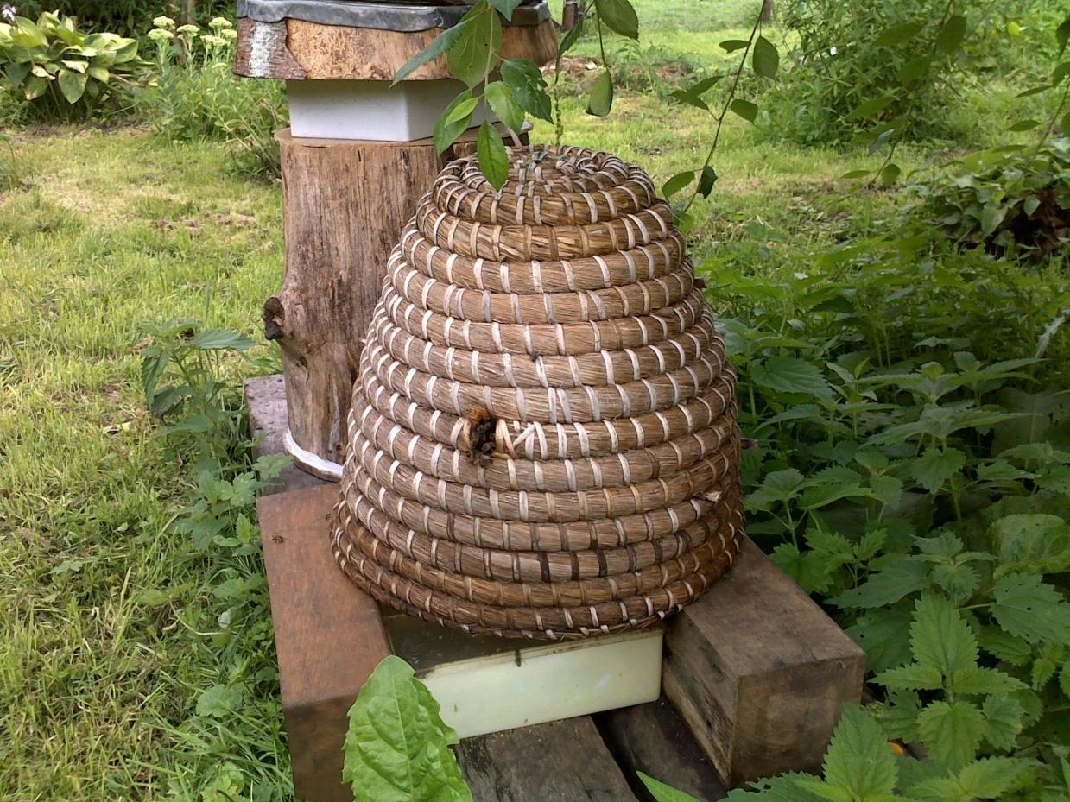](http://www.google.nl/url?sa=i&rct=j&q=&esrc=s&source=images&cd=&cad=rja&uact=8&ved=0ahUKEwio5Iuq7J_WAhVCElAKHZpoAf0QjRwIBw&url=http%3A%2F%2Fwww.rivendellvillage.org%2Fapicultuur.htm&psig=AFQjCNGm5ZzxO_51RQeeQMCRAt88AZG_qQ&ust=1505312532767846)

Wie woont hier?

[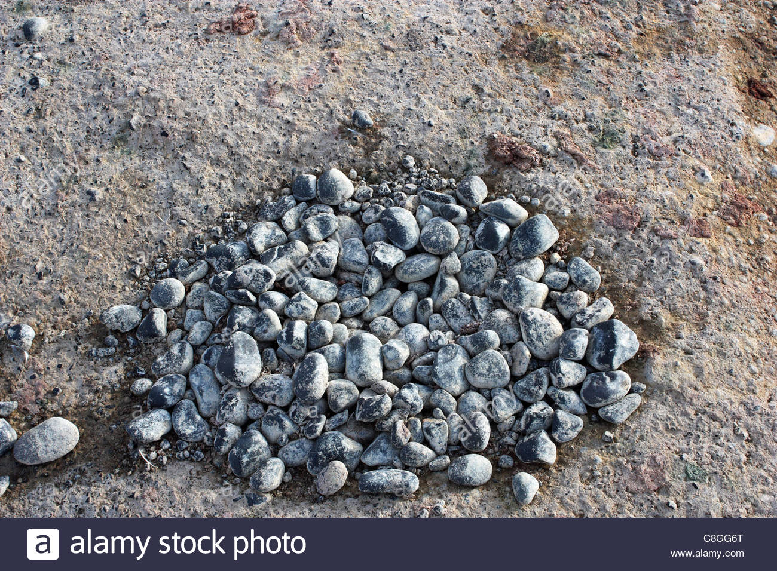](http://www.google.nl/url?sa=i&rct=j&q=&esrc=s&source=images&cd=&cad=rja&uact=8&ved=0ahUKEwiSudbM7J_WAhVCKFAKHeIYAqgQjRwIBw&url=http%3A%2F%2Fwww.alamy.com%2Fstock-photo-close-up-of-an-adelie-penguin-pygoscelis-adeliae-pebble-nest-39701952.html&psig=AFQjCNHAmpE6ZN73CeclU4gW5ZdFi_VG_Q&ust=1505312565703808)

Wie woont hier?

[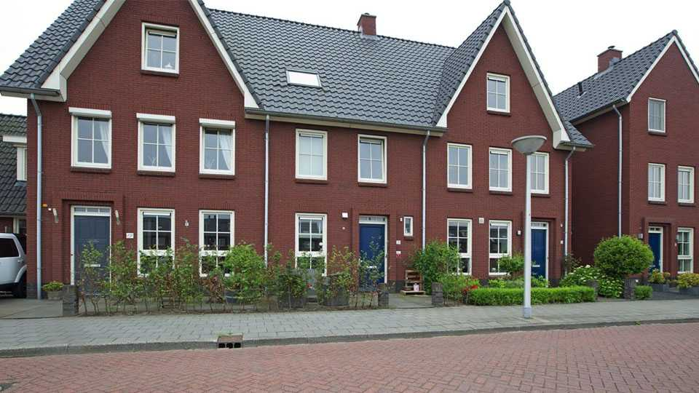](https://www.google.nl/url?sa=i&rct=j&q=&esrc=s&source=images&cd=&cad=rja&uact=8&ved=0ahUKEwi70qH67J_WAhUDb1AKHaQQCscQjRwIBw&url=https%3A%2F%2Fwww.bekendeburen.nl%2Fnederlands-elftal-speler-joel-veltman-zet-zijn-huis-te-koop&psig=AFQjCNEnHoGPeH69m8Kjphd3NoRXAGjbmA&ust=1505312657668010)

Wie woont hier?

[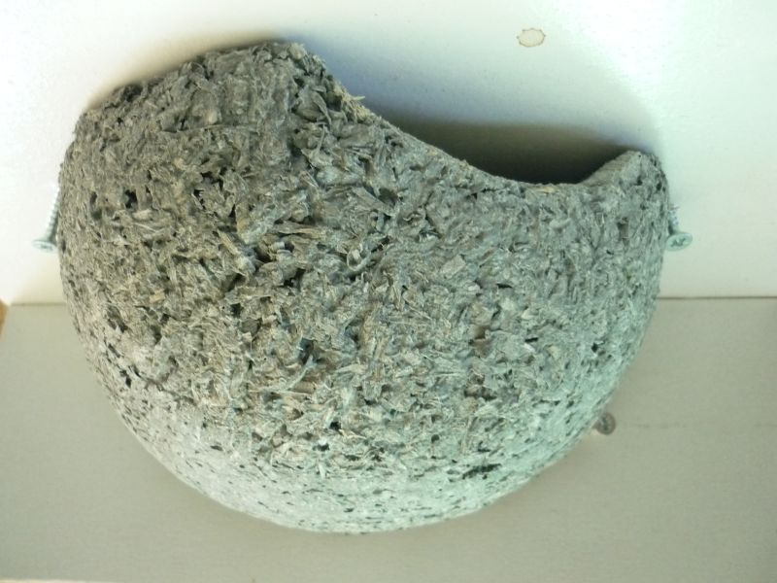](https://www.google.nl/url?sa=i&rct=j&q=&esrc=s&source=images&cd=&cad=rja&uact=8&ved=0ahUKEwiXo5WY7Z_WAhWFJ1AKHVSwBWUQjRwIBw&url=https%3A%2F%2Fbeilen.groei.nl%2Findex.php%3Fid%3D37792&psig=AFQjCNGWDmLGOomfUzkbuwXgAtXW-I9PtQ&ust=1505312729630091)

Wie woont hier?

[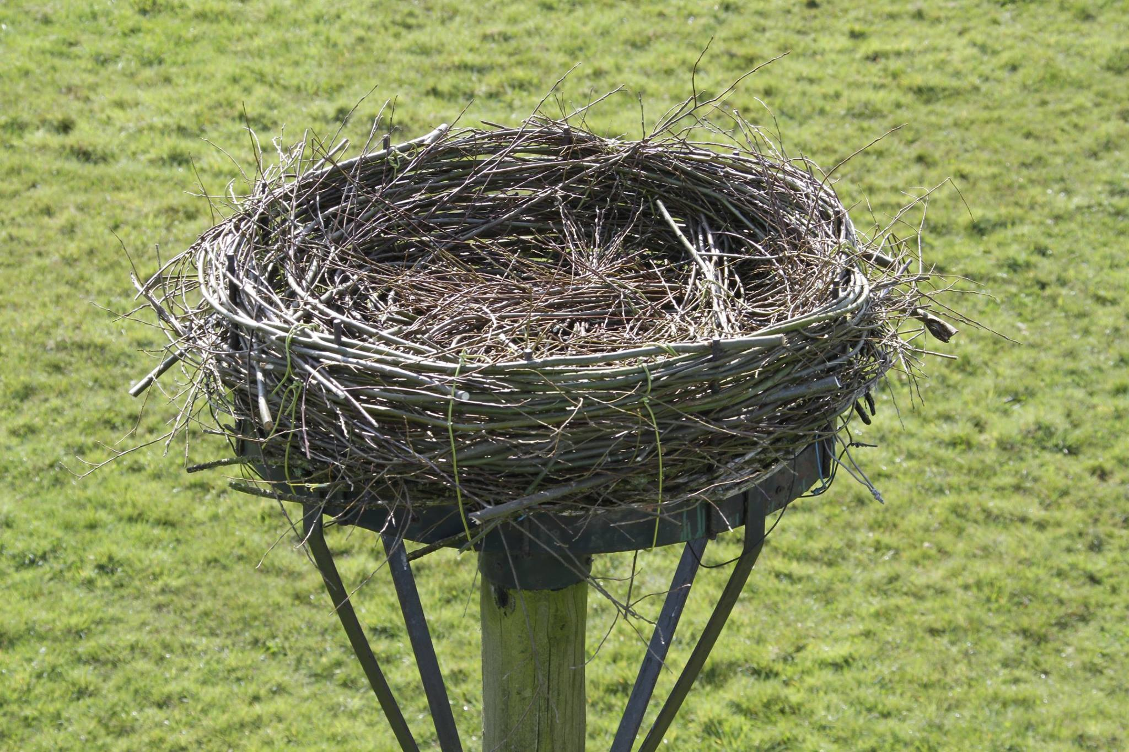](http://www.google.nl/url?sa=i&rct=j&q=&esrc=s&source=images&cd=&cad=rja&uact=8&ved=0ahUKEwi2sL_K7Z_WAhWSaVAKHUVuD0wQjRwIBw&url=http%3A%2F%2Fwww.deharkema.frl%2F2016-04-13%2Fooievaarsnest-op-het-themapark&psig=AFQjCNFCL3Mgn0eKQQn5E1Zz-kuXk6BXmQ&ust=1505312870521296)

Wie woont hier?

[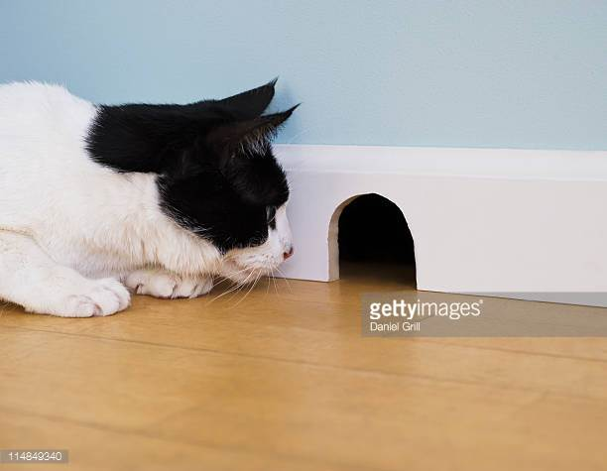](http://www.google.nl/url?sa=i&rct=j&q=&esrc=s&source=images&cd=&cad=rja&uact=8&ved=0ahUKEwjXqLWO7p_WAhXHIlAKHacPAuwQjRwIBw&url=http%3A%2F%2Fwww.gettyimages.com%2Fphotos%2Fmouse-hole&psig=AFQjCNG1oHv09tAaCXTaRU74evMak0f2lw&ust=1505313012762578)

Wie woont hier?

[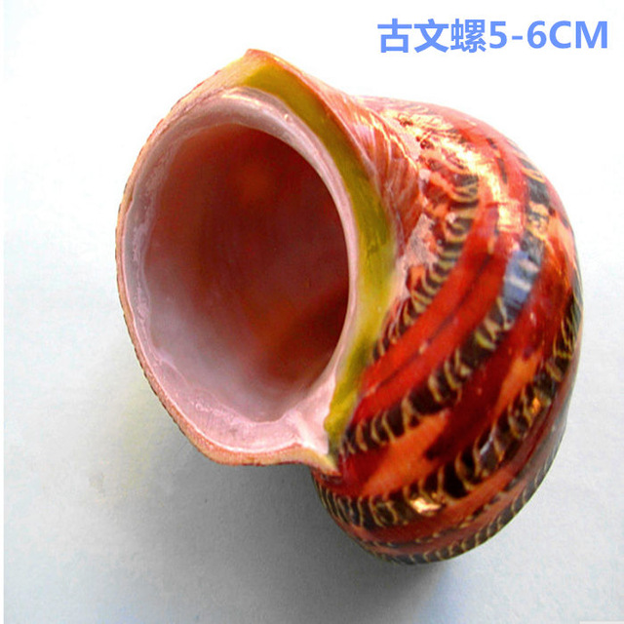](https://www.google.nl/url?sa=i&rct=j&q=&esrc=s&source=images&cd=&cad=rja&uact=8&ved=0ahUKEwiWh4bD7p_WAhWOYVAKHctJBAIQjRwIBw&url=https%3A%2F%2Fnl.aliexpress.com%2Fstore%2Fproduct%2FNatural-conchas-shells-coil-ancient-hermit-crab-fish-aquarium-accessories-beach-wedding-decoration%2F617967_32712378129.html&psig=AFQjCNHrTKrJfrusftm6S8Z91yzObQRcuA&ust=1505313107827111)